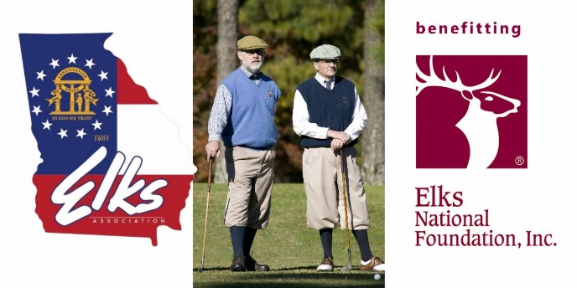

The G.E.A. 2026 E.N.F. Golf Tournament
will be held on
Saturday May 16th at 9:00 A.M.
at the
Calhoun Elks Lodge Golf Course
143 Craigtown Rd NE
Calhoun Ga 30701
Registration Starts at 9:00 AM Shotgun Start at 10:00 AM

Entries will be 4-person teams $125.00 per player.
This includes your round of golf and lunch at the course.

WE ARE ASKING EVERY GEORGIA LODGE to
Sponsor a team for $500 and
Sponsor a hole for $100.00

If you'd like to register, or
if you or your Lodge would like to sponsor a hole,
﻿please contact -
BRIAN RUSSELL
PHONE: 706-599-4351
EMAIL: brianr79@yahoo.com

